66
Omar abuhassan 22110264
Islam Alomari
Abstract
[Draw your reader in with an engaging abstract. It is typically a short summary of the document.
When you’re ready to add your content, just click here and start typing.]
Technical Report
Organization Name

Contents
1 Introduction 2
2 Organizational Study 4
2.1 Identify the organization 4
2.2 Features and the operational areas of the selected organization 5
2.3 Stakeholders 6
2.4 Challenges to the success of the organization's business 7
2.5 Business Requirements 8
3 Research Study 8
3.1 Research Overview 8
3.2 Analysis of Collected Data and Description of Generated Knowledge 15
3.3 Research Findings 21
4 References Include proper citations for the research papers in Harvard format. 23

Introduction

The term big data refers to the massive amounts of data generated from various sources at high speeds. Analyzing this data can lead to system development, discoveries, and new decisions(Jamarani et al., 2024). The 6V’s of Big Data are: Volume, representing the vast amount of data generated daily; Velocity, the speed at which data is processed and generated, especially with many devices connected to the Internet; Variety, the different types of data such as text, images, and videos; Veracity, the accuracy and quality of the data; Value, the usefulness of data in making decisions; and Volatility, the extent to which data can change, requiring modern technologies to manage it effectively.
The most prominent tools and techniques that help institutions deal with big data include the Hadoop platform, which provides open sources that contribute to storing and processing huge amounts of data. NoSQL Database is designed to deal with all types of data, including structured and unstructured data, where it stores and organizes data, through which you can query the saved data. Elasticsearch search engine and data analyst provides a high-speed search, query, and analysis environment. MapReduce is a model that mainly generates and processes big data and is primarily included in the Hadoop platform. (Xu, Frankwick and Ramirez, 2016) Machine learning and deep learning applications and programs, in cooperation with data representation applications, work on studying and analyzing data to extract realistic predictions that develop the company's work. To ensure the protection of all the above, encryption tools and applications such as Apache Ranger are used(Matturdi et al., 2014).

The main and basic problem in dealing with big data is how to store and save this data because it needs a huge amount of modern technology to maintain it, and we cannot forget the analysis and processing of this data, as its size will be a major obstacle for programmers and specialists. One of the complex difficulties is also the way to preserve the information, due to its huge size, it often contains sensitive data that should not be shared with others. However, through the huge amount of data and after analyzing it, discoveries can contribute to the success of the company and can also develop existing operations. Analysis can increase efficiency by providing vision and predictions of future trends. The marketing department collects the most opportunities from big data, as analyzing data on customer behavior and interests directs new marketing campaigns and helps analyze the market situation to predict the future state of the market, leading to better-informed investment decisions(Janssen and Kuk, 2016), (Nazir et al., 2020).

Here and in this report, I will study the actual impact of the use and possession of big data on Zain, the main goal is how the analysis of that data can affect and even be the main reason in the decision-making process of the company's income, but in particular, the goal is to answer the following question:
How can Zain, through big data analysis, improve the company's business results and put it at the forefront of the competitive race?
We will do this through key factors that in turn contribute to strategies that use data and implement company insights.

Organizational Study

Identify the organization
I started looking for companies that deal with big data or that they already have big data, then I listed those companies and chose the ones I know people who work for them or that I can visit and started sending them an e-mail where I sent them to the following companies: Aramex, Vettel, eFAWATEERcom, Jordan Islamic Bank, Orange. I was met with rejection or no response from all of them until I contacted Zain and was met with a positive reply and agreed to help with the report and here, I attach the mail that I sent and the reply I got

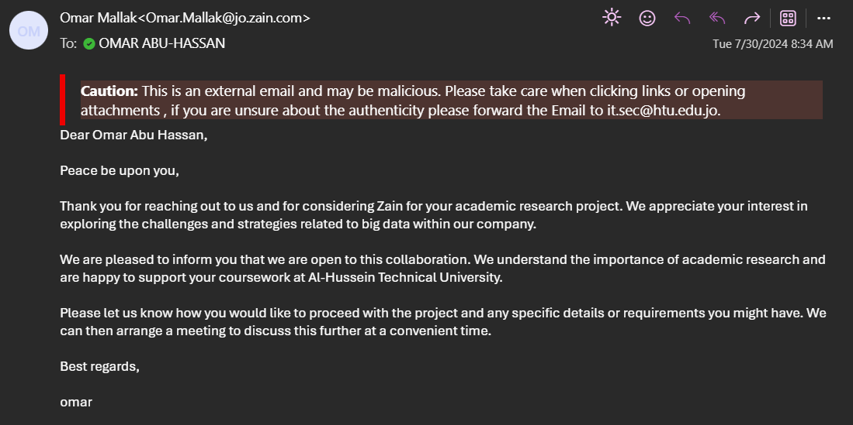

Features and the operational areas of the selected organization
In order to understand the impact of data, it is necessary to study the features of the operational areas in the company and how they support its purpose. Here I will study five of the functions in order to illustrate how these functions benefit from data analysis to enhance decision-making and improve the company.

1- Customer Service:
- Analyze data related to customer interaction in order to identify problems and facilitate the process of solving them
- Using opinion polls and analyzing their data in order to know the extent of customer satisfaction with the service in order to develop features and try to avoid negatives
- Analyze historical data and use machine learning and artificial intelligence in order to predict customer needs and present them ahead of time to customers
2- IT:
- Optimization and development of infrastructure by monitoring network performance and analyzing records in order to ensure that data is preserved
- Conducting big data events
- Enhance cybersecurity through security analytics
- Facilitate the integration of the company's analytics tools
3- Marketing:
- Promote advertising and increase spending - studied - on them
- By studying the previous data, analyze and select the target audience in order to facilitate the arrival of advertising campaigns
- Monitor the impact of ads through social analytics
4- Sales:
- Study and analyze data in order to determine customer purchasing trends in order to determine the most appropriate prices
- Determine purchasing habits for promotional decision decisions
- Use forecasting tools to forecast sales and prepare a production control plan

5- Finance:
- Prepare a financial management plan and clarify an alternative plan in case of risks
- Create thoughtful financial projections based on the analysis of past data

Stakeholders
The role of stakeholders cannot be underestimated since they play a major part in the company’s success due to their involvement with strategy making and ensuring that the company runs efficiently.
- Internal Stakeholders:
- Management: It is the structure within which decisions are made and strategies implemented, this part of management that big data affects by giving insight to market trends, date about company performance details as well customer preferences consequently it must be very clear, focused allowing top manager to make an educated decision in building a better corporate strategy.

- Employees: The Company operates and performs their duties for this system every day
Data analysis affects employees by improving productivity as they now perform tasks that are routine and help train new hires, which in turn improves the company's innovation and performance.

- Shareholders Their role is to invest in the capital of the company, which angles for financial returns and data analysis can show how profit happens as situationally improving plan then help boost investment flow on that stock

- External Stakeholders:
- Suppliers: They are responsible for providing materials and services to the company, their work is affected by analytics that provide sales forecasts, which may affect the amount of demand, relationships with suppliers can lead to the possibility of saving prices and improving services

- Customers: They are those people who benefit from the services provided by the company and they are the main cause of revenues, the actual impact of them in the company lies in the increase in revenues and the rise in the market ratio, and that is through the analysis of data that concerns them, including: the most preferred services, their behavior towards a particular advertisement and service, their opinions through customer service (in cooperation with them).

- Government is the one that monitors the company from compliance with laws and ensure industrial standards for products, compliance with government standards and requirements is critical for Zain, and through big data they can monitor compliance and observance of regulations, and they can also provide programs to obtain support and cooperation from government agencies.

- Community: It is the social and economic environment in which the company operates, and their impact lies in that they are able to improve the company's reputation, which leads to the survival of the company, and this is through the analysis of big data and through understanding and studying that analysis can provide services and products needed by members of society and have an actual impact on their daily lives

Challenges to the success of the organization's business
- One of the most important criteria for the success of companies in general and Zain in particular is to evaluate the challenges that the company may face, and the most famous of these challenges are: change management, change implementation, adherence to standards, communication with stakeholders.

- Change management: including (expansion, diversification, systems modernization)
These changes may be crippling and have a negative impact in order to ensure negative change, this stage requires the company's management to plan effectively in order to reduce the most problems that the company may face, and the plan must concur ,all the details regarding the duration and resources and even it must contain the problems that may occur and it is possible that informing stakeholders of the change in advance may greatly facilitate the process

- Implementation of change: The implementation of change requires following the plan that has been developed by the change management team, failure to follow it may lead to delay or cost overruns and may reach total failure, so it is possible to follow a project management methodology in order to organize change with high efficiency and it is possible to appoint managers with competence in the field of change management and the process must be fully monitored in order to try to adapt to any emergency that may occur during the change All this can increase the likelihood of successful implementation.
- Compliance with standards: It is imperative for Zain to take into account that it moves under an environment of modern regulations that govern privacy and cybersecurity, failure to comply with such regulations leads to legal problems and direct damage to the company's reputation, which affects customer confidence, to avoid this it is necessary to comply with these regulations and work to update and develop them periodically, and work on effective data protection measures, these procedures may lead to mitigating challenges

- Communication with stakeholders: This is divided into two main points:
- Communicating the need for change: The process of communicating the idea of the need for change to them can be difficult, especially if their consent is not approved, this may lead to a decrease in support for change initiatives, so a strategic plan must be developed that develops the reasons for change and the actual benefit of it and how it will affect them and transparent communication can help in the process of addressing rejection and help increase support
- Involving them in change: Their survival in supporting change is very important in order to achieve success, in the absence of a strong and highly efficient management of change, stakeholders may feel neglected and may lead to their resistance to the process of change, which in turn may negatively affect the process of change, and in order to avoid this, they must be involved early in the change, and they have access to adequate information and training (if necessary) and inform them of the goal of change and monitor the response Their action and opinions about change and dealing with those opinions may maintain their satisfaction with the change.

Business Requirements
1- Enhancing the role of analytics in decision-making processes: The goal is to reach 75% of the departments that rely mainly on data and analysis within a maximum period of one year
2- Addressing privacy concerns: by applying strict protection protocols and complying with information security regulations, the goal is to reach the level of fear and anxiety to less than 5% within 6 months
3- Developing expertise: through training courses and workshops, the goal is to reach the percentage of employees with competence and experience in dealing with big data and its analysis to at least 50%, within a maximum period of two years.

Research Study

Research Overview
Methodology used in research and sampling The research aims to study how Zain benefits from big data in order to enhance business functions and increase efficiency and aims to identify the areas that benefit most from data in order to develop it and how data affects it.
This research is designed to combine qualitative and quantitative methods in order to ensure the collection of data from people with different backgrounds while considering scientific and specialized opinion.
A questionnaire was sent that combines topical questions (with a specific answer), and general questions (with an open answer) to the person who is a mediator, with the aim of collecting data on the extent of benefiting from their data and analysis, as well as addressing the challenges facing employees and their satisfaction, and general questions allowed experts to share their experiences in evaluation and develop notes that would help in development.
Participants from different departments were selected according to their participation in the use of data and its analysis in their daily jobs, through a secure electronic survey, including a variety of questions that support the research, and those data were analyzed to benefit from them.
All participants have been informed that the research is for scientific purposes and that the data will not be published or shared with any person who is not authorized to research, in order to preserve the scientific honesty and privacy of the participants.

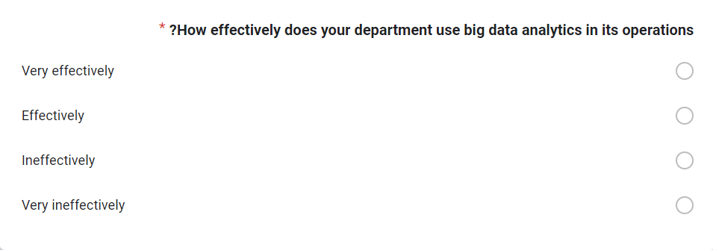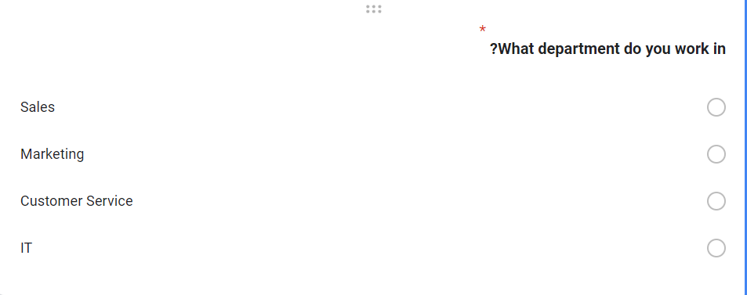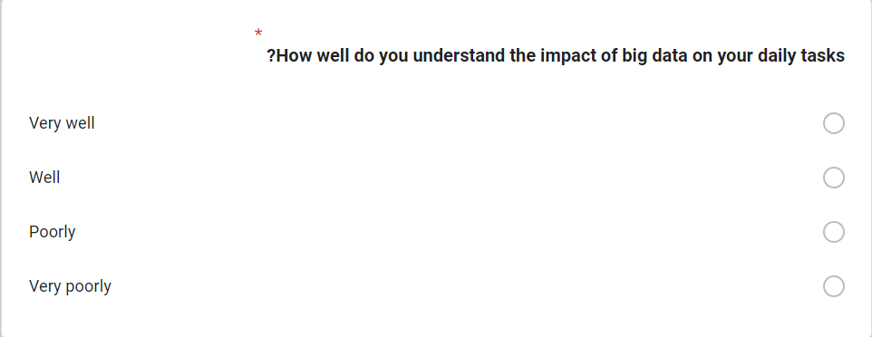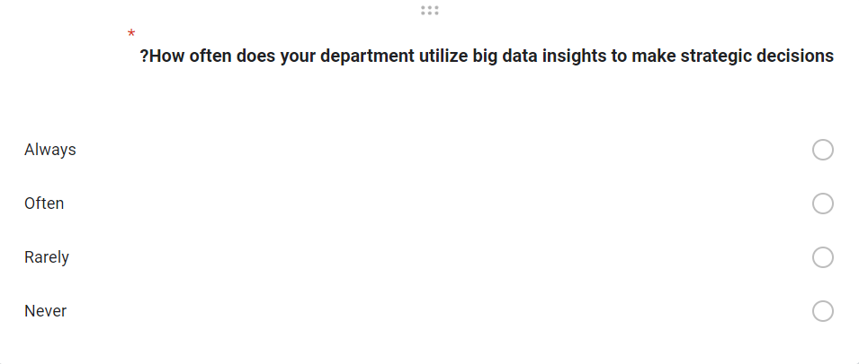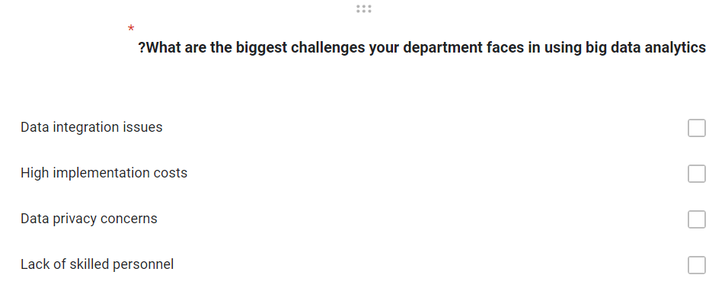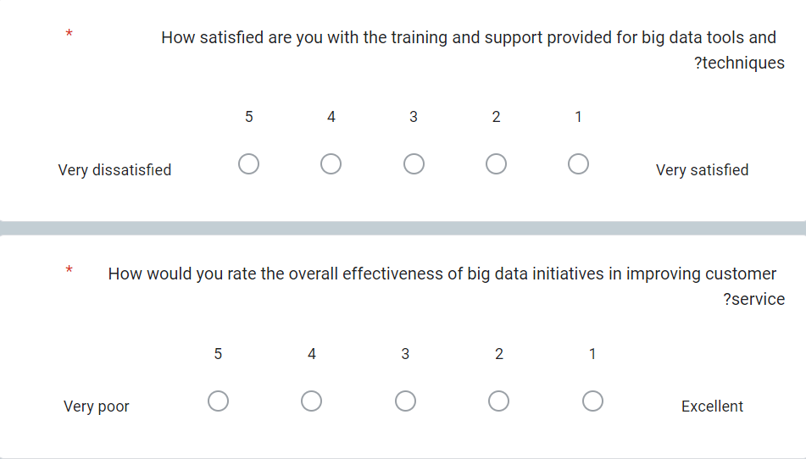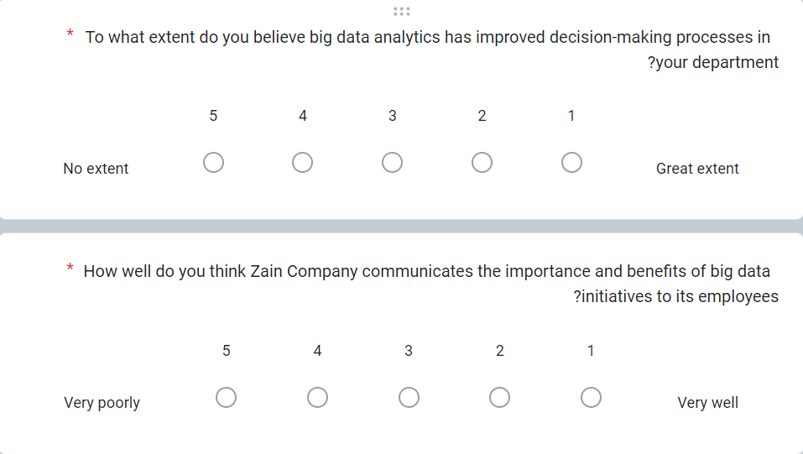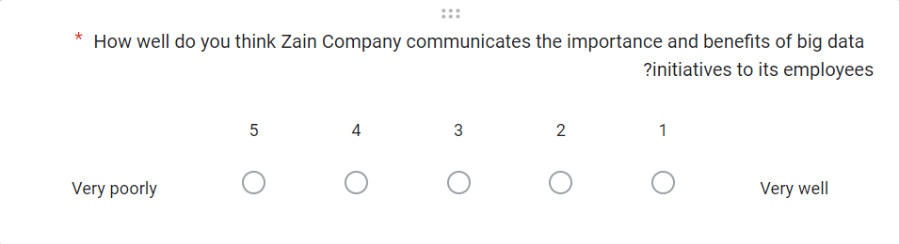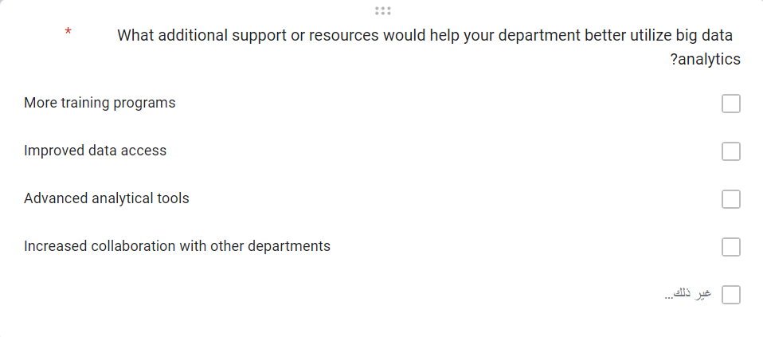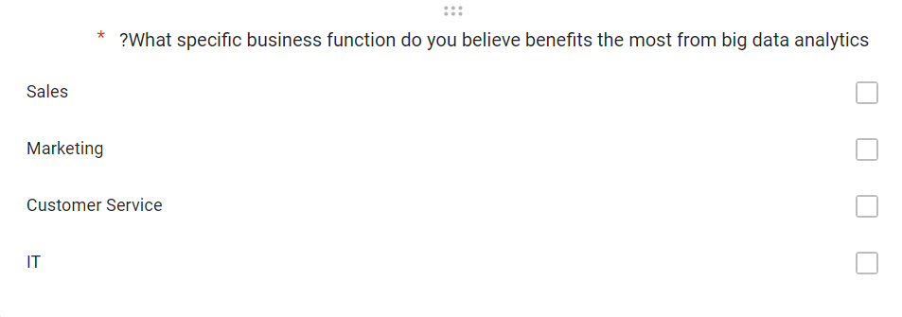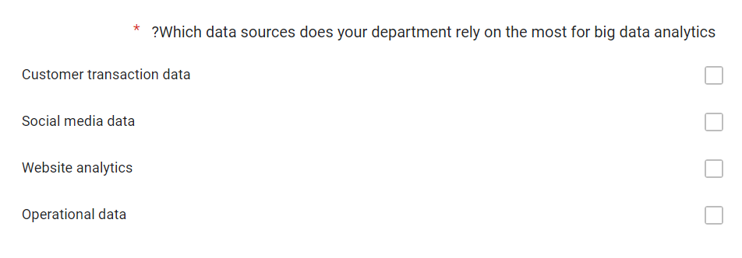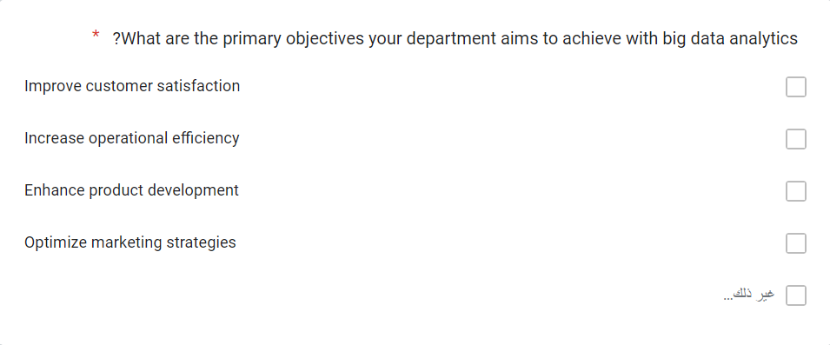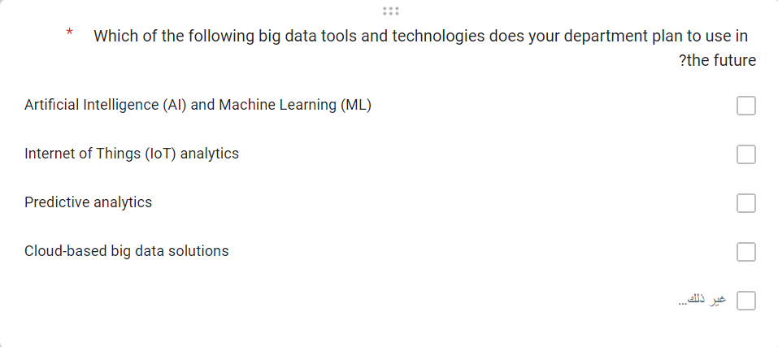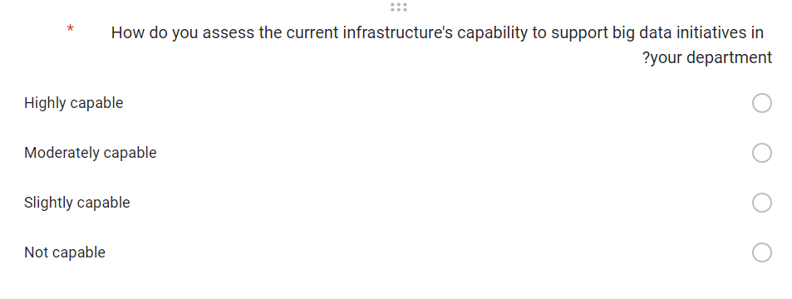

Analysis of Collected Data and Description of Generated Knowledge

1. This picture shows the extent of effective use of big data in various departments, as the largest percentage of departments use this data effectively and the small percentage uses it very effectively, while the middle ratio is equal between inefficient and very inefficient use.

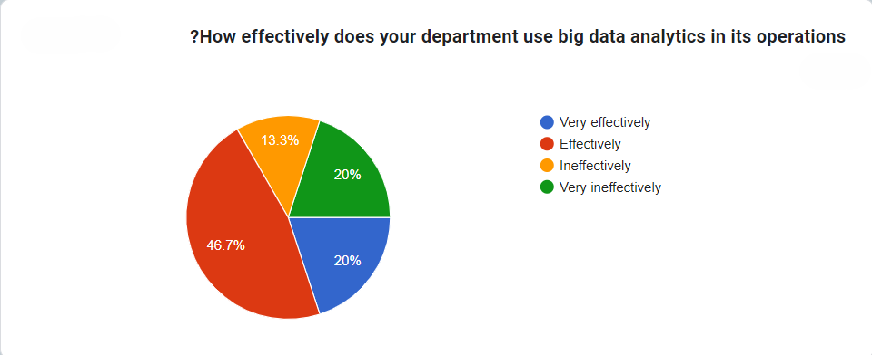
2. This image shows the extent to which people understand the impact that big data analysis has on daily tasks, as it shows that the vast majority of employees provide a good understanding of the impact, while the ratio between those who provide a full understanding, and no understanding of the impact is equal
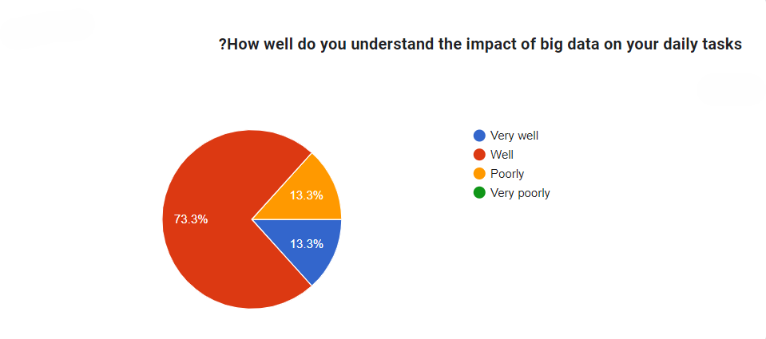

3. This image shows the extent to which data and its analysis are used to make decisions, as it was found that nearly half of them are always using these analyzes, while the percentage of those who use them often exceeds a quarter and the rest of them rarely use them.
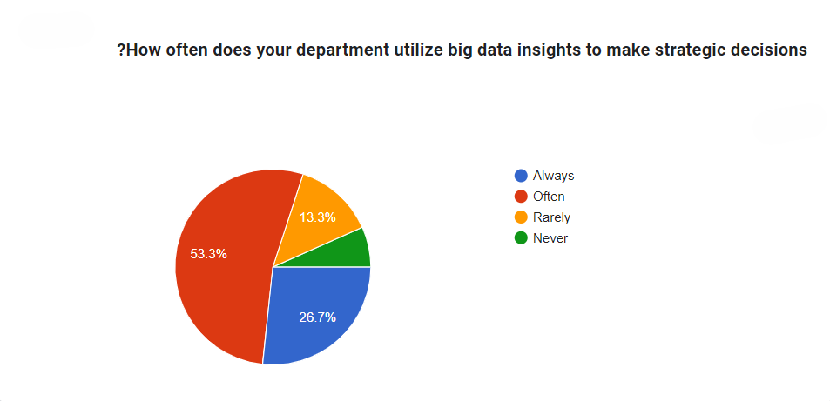
4. This chart shows the challenges facing departments, as it shows that 40% of concerns are related to privacy, while 27.7% appear for the problem of costs, and the same percentage shows the problem of integration, while the results showed 6.6% of concerns related to labor shortage.
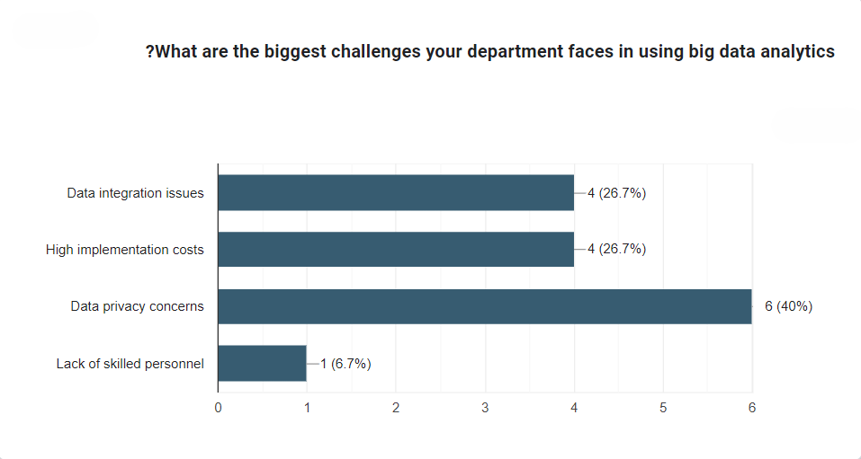

5. This picture puts the extent of satisfaction with the training and support that people get to deal with big data and its tools, and shows that 20% of them are very satisfied, while nearly half of them expressed a neutral opinion, and the rest of the opinions varied between satisfied and dissatisfied.
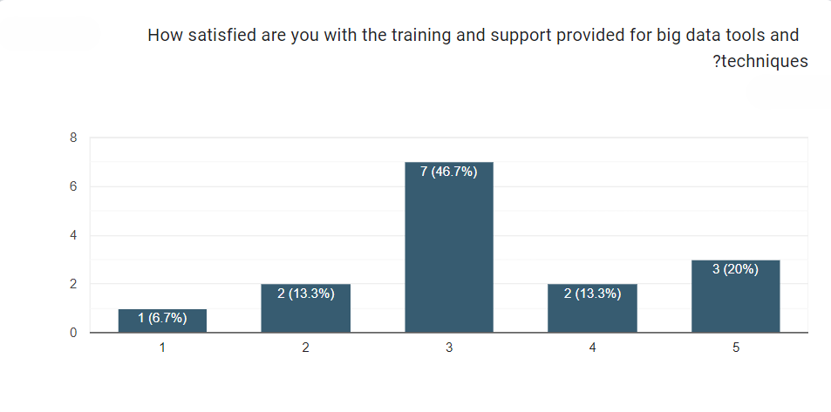
6. This picture shows the overall effectiveness of big data initiatives in improving customer service, as the largest percentage sees it as effective, and the small percentage sees it as effective for the expensive and the rest of the percentages vary and show that it is ineffective
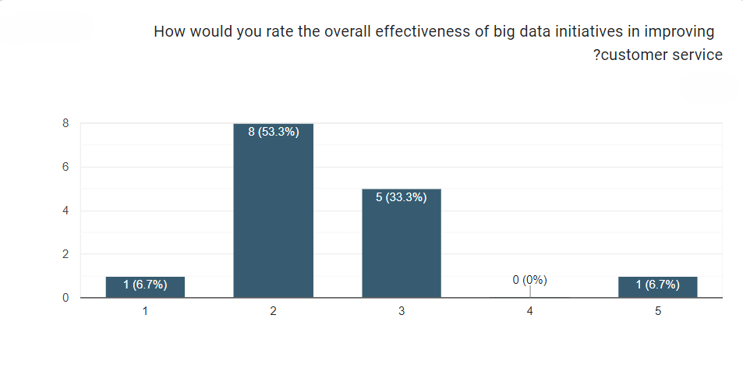

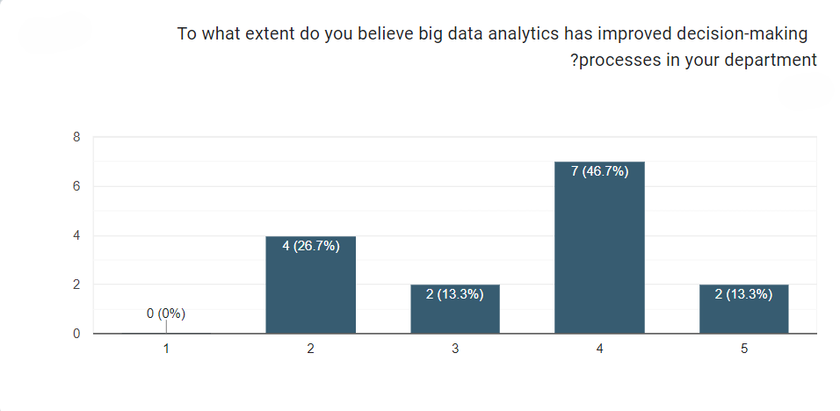
7. This picture shows the extent to which people believe that data analytics has improved the decision-making process, as almost half have noticed that the improvement exists, while the ratio is equal between those who believe that change exists for the precious and those who see it as moderate, while the percentages showed that nearly a quarter of them believe that the improvement appeared, but in a small way

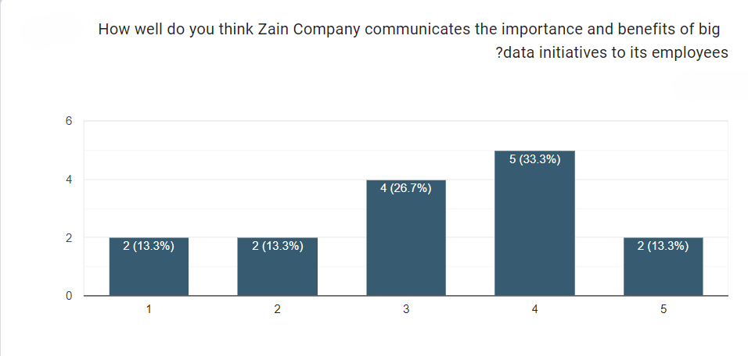
8. This image shows the extent of the company's success in communicating the importance of big data initiatives to employees, where the percentages show great convergence, the largest percentage shows that the company succeeded moderately, and the smallest percentage shows that it failed

9. This picture shows the general need for resources and support that departments need to make better use of data, as it showed that the largest percentage believes that increasing cooperation between departments is the most important thing, while the small percentage showed an equal percentage of: training for employees, qualified employees, artificial intelligence team
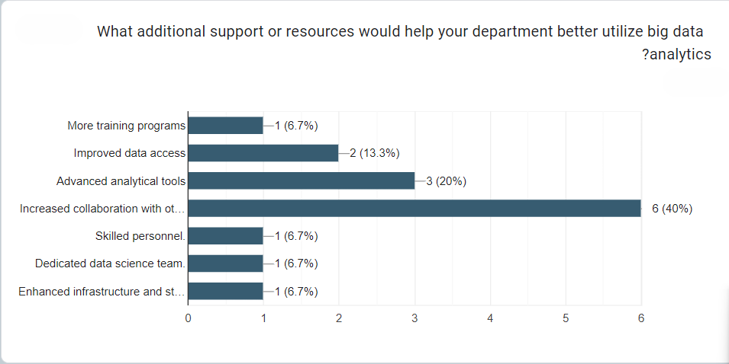
10. This picture shows the departments that benefit the most from big data, and the largest percentage sees that the IT department is the most benefiting while the sales department is the least benefited
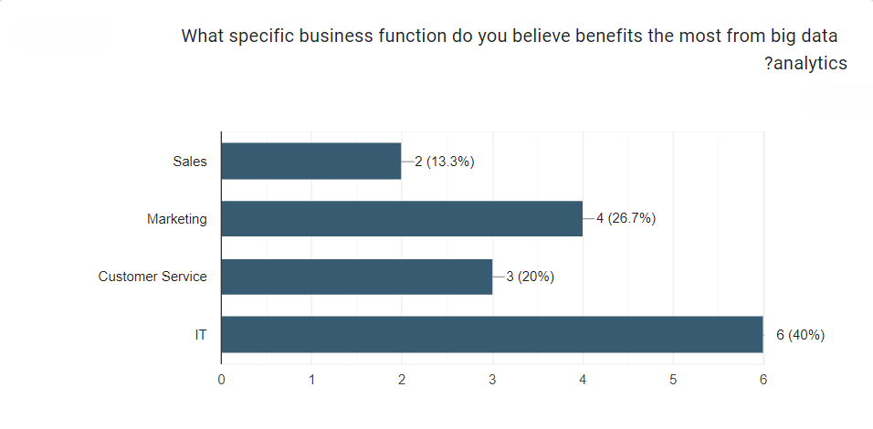

11. This picture shows the sources on which the company relies to obtain data, where the largest percentage shows that the company obtains its data from customer transactions, while the middle percentage is equal that the company obtains it from social networking sites and site analytics, while the smallest percentage shows that it obtains it from operational data.
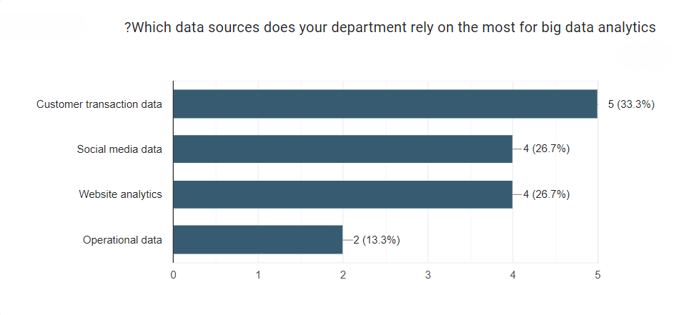
12. The picture shows the objectives of the departments from the use of big data, as it shows that the largest percentage of departments aims to increase operational efficiency
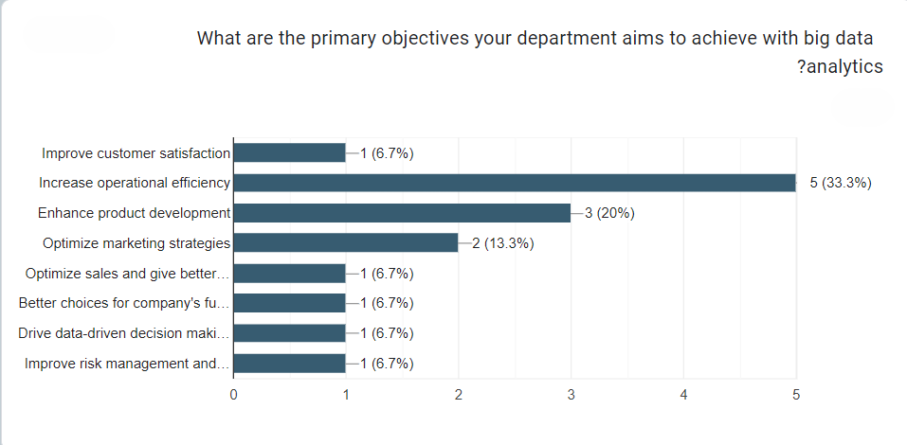

13. The image shows the tools to be used in the future, showing that nearly half want to use artificial intelligence and machine learning, while the smallest percentage got data processing and analysis in real time.
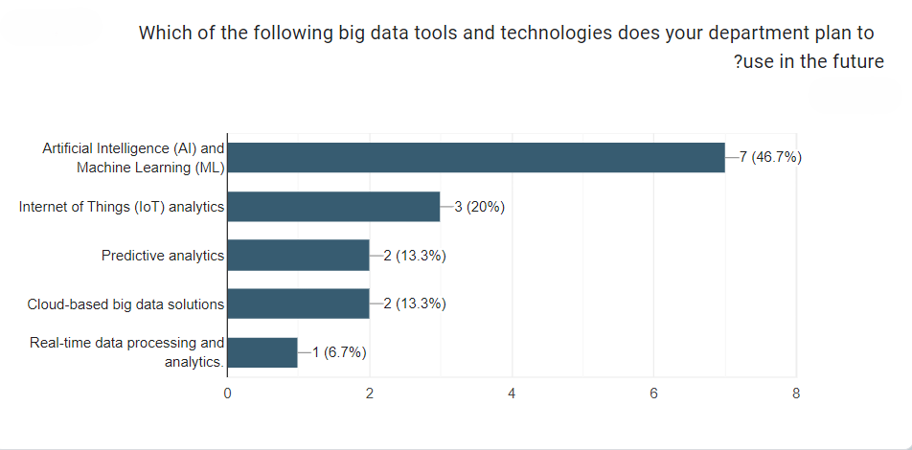

14.This image shows an assessment of the capacity and suitability of the infrastructure to support big data initiatives in the departments
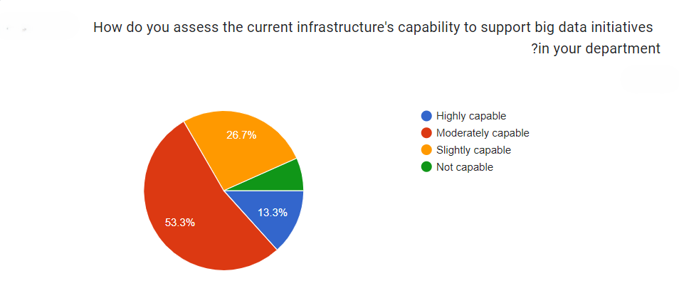

Research Findings
The main purpose of this research is to evaluate the situation of Zain and its work with big data analytics (challenges and opportunities) and after asking employees from more than one department about big data and how the departments deal with it, it was reached
Compliance with business requirements:
After analyzing the questionnaire data, it was concluded that data analytics in the company has a major role in decision-making, as 46.7% of the target group believes that data analytics improved the decision-making process, and then it also led to an increase in operational efficiency, as 33% of them said that increasing operational efficiency through analytics is one of the most important goals in his department, and the results showed that 20% believe that analytics led to improved customer service.
Main problems:
The analysis of the results of the research showed that there is a dilemma in data analysis, as 20% of the targeted people see it as ineffective or that it is ineffective at all, in addition, 13.3% of them said that their departments rarely use data analytics in decision-making processes, and the results of the research showed that 40% of them have concerns about data privacy, and 26.7% see that there are problems in data integration, and the biggest problem shown by the results is that 6.6% of them He stated that there is a lack of expertise and competencies in dealing with big data

References
Include proper citations for the research papers in Harvard format.
Jamarani, A. et al. (2024) 'Big data and predictive analytics: A sytematic review of applications,' Artificial Intelligence Review, 57(7). https://doi.org/10.1007/s10462-024-10811-5.
Janssen, M. and Kuk, G. (2016) 'The challenges and limits of big data algorithms in technocratic governance,' Government Information Quarterly, 33(3), pp. 371–377. https://doi.org/10.1016/j.giq.2016.08.011.
Matturdi, B. et al. (2014) Big Data security and privacy: A review. https://www.semanticscholar.org/paper/Big-Data-security-and-privacy%3A-A-review-Matturdi-Zhou/829d095f8c24282feead97be2e9f967082410300.
Nazir, S. et al. (2020) 'A comprehensive analysis of healthcare big data management, analytics and scientific programming,' IEEE Access, 8, pp. 95714–95733. https://doi.org/10.1109/access.2020.2995572.
Xu, Z., Frankwick, G.L. and Ramirez, E. (2016) 'Effects of big data analytics and traditional marketing analytics on new product success: A knowledge fusion perspective,' Journal of Business Research, 69(5), pp. 1562–1566. https://doi.org/10.1016/j.jbusres.2015.10.017.

